Backend System for Single-Use Tokens in Two-Factor Authentication
Submitted by: Muhammad Mumtaz
- Introduction
The world seems to take data security and user privacy very seriously today; therefore, 2FA (two-factor authentication) has emerged as a critical layer of protection against unauthorized access. This paper describes the AWS Serverless 2FA Token Service, an implementation of the proof of concept, which is created to generate and deliver single-use tokens in 2FA workflows.

Objective: Providing a secured, serverless backend service that is efficient in generating and delivering one-time authentication tokens is the primary objective of this system. The AWS service utilization in the system lowers operational expenditure and complexity while maintaining high scalability and security levels.

Scope: This document details the architecture of the proposed system, implementation steps, as well as security best practices. A module design which enables easy maintenance and future enhancement along with resilience features ensuring high availability and reliability are also included in the document. It also specifies deployment and testing functionality guidelines for ease of implementation and verification of the service by users within their environments.

- Architecture Overview
The AWS Serverless 2FA Token Service is designed as a highly scalable and secure system for generating and delivering single-use tokens for two-factor authentication. The architecture leverages various AWS services to ensure a serverless environment that is both resilient and modular.

Key AWS Services Utilized:
- AWS Lambda: Provides serverless compute capabilities to execute the token generation and validation logic without managing servers.
- Amazon DynamoDB: Acts as the primary data store for managing token information and their associated metadata.
- Amazon SES (Simple Email Service): Facilitates the delivery of verification tokens via email to users.
- Amazon API Gateway: Exposes RESTful API endpoints to handle requests for token generation and validation.
- AWS IAM (Identity and Access Management): Secures the environment by managing permissions and access controls for different AWS services.

Architecture Diagram: The architecture of the AWS Serverless 2FA Token Service is designed to facilitate seamless two-factor authentication through a series of interconnected components. At the core, users initiate the process by interacting with the API Gateway, which exposes endpoints for token generation and validation. The gateway routes these requests to AWS Lambda functions that handle the business logic, including the generation of secure tokens and verification codes. The generated tokens are stored in DynamoDB, ensuring quick access and efficient data management. For token delivery, the service integrates with Amazon SES to send emails containing the verification codes to users. Additionally, CloudWatch monitors the entire system, providing insights into performance and health metrics, which helps maintain resilience and reliability across all components. This modular design enhances scalability while keeping the overall architecture simple and effective for secure authentication workflows.
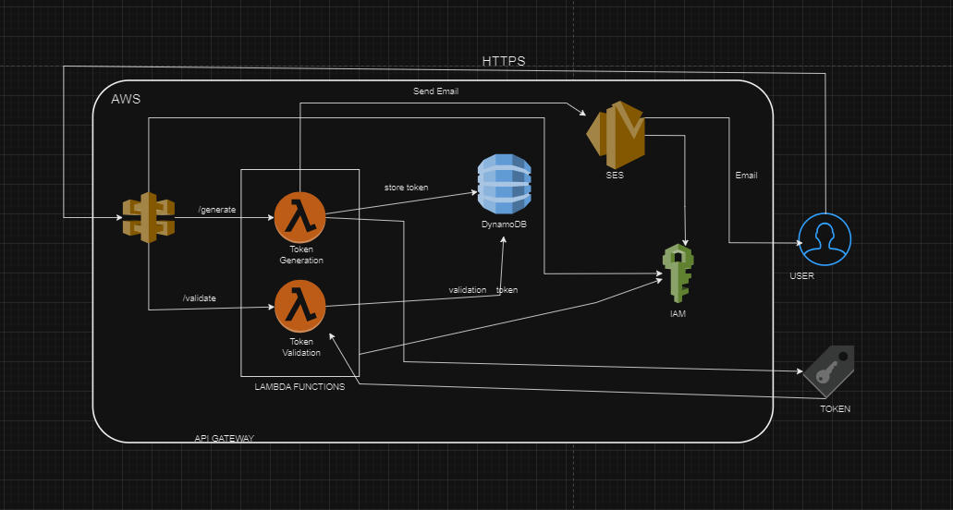

- System Components
The AWS Serverless 2FA Token Service is built using a collection of AWS services that work together to provide a secure and efficient two-factor authentication solution. The following are the key components of the system:

  - API Gateway
The API Gateway serves as the entry point for all client requests. It exposes two main endpoints:
- /generate-token: This endpoint handles requests to generate and send authentication tokens to users.
- /validate-token: This endpoint is responsible for validating the tokens provided by users during the authentication process.
The API Gateway is configured to integrate seamlessly with AWS Lambda, allowing it to trigger the appropriate Lambda functions based on incoming requests.

  - AWS Lambda
The backbone of the application logic is provided by AWS Lambda, which offers serverless compute capabilities. The system utilizes two primary Lambda functions:
- Token Generation Function: This function generates a secure token and a verification code, stores them in DynamoDB with an associated expiration time, and sends the verification code to the user via Amazon SES. It ensures that tokens are generated efficiently and securely.
- Token Validation Function: This function receives a verification code from the user, checks its validity against the stored tokens in DynamoDB, and deletes the token upon successful validation to enforce its single-use policy. This ensures that the token can only be used once, enhancing security.
  - Amazon DynamoDB
DynamoDB is the NoSQL database used to store tokens and their associated metadata, such as expiration times and verification codes. Its high availability and low-latency characteristics make it well-suited for this application, allowing for rapid access and efficient management of token data. The use of DynamoDB ensures that the system can scale seamlessly with increasing user demand.

  - Amazon SES (Simple Email Service)
Amazon SES is utilized for delivering verification codes to users via email. This service enables the application to send emails securely and efficiently, allowing users to receive their tokens promptly. SES ensures that the email delivery process is reliable and can be scaled as needed.
  - CloudWatch
Amazon CloudWatch is employed to monitor the health and performance of the system. It tracks key metrics related to Lambda function executions, API Gateway requests, and DynamoDB operations. This monitoring capability allows for proactive management of the system, ensuring high availability and quick identification of any potential issues.
  - AWS IAM (Identity and Access Management)
AWS IAM is used to manage permissions and access controls for the various AWS services involved in the application. It ensures that each component of the system operates with the principle of least privilege, thereby enhancing the overall security posture of the application.
Together, these components create a robust, serverless architecture for generating and validating single-use tokens, facilitating a secure and efficient two-factor authentication process

- Code Excerpts/Snippets
I have implemented the solution in Python. The following subsections contain the code snippets.
  - Token Creation Lambda Function
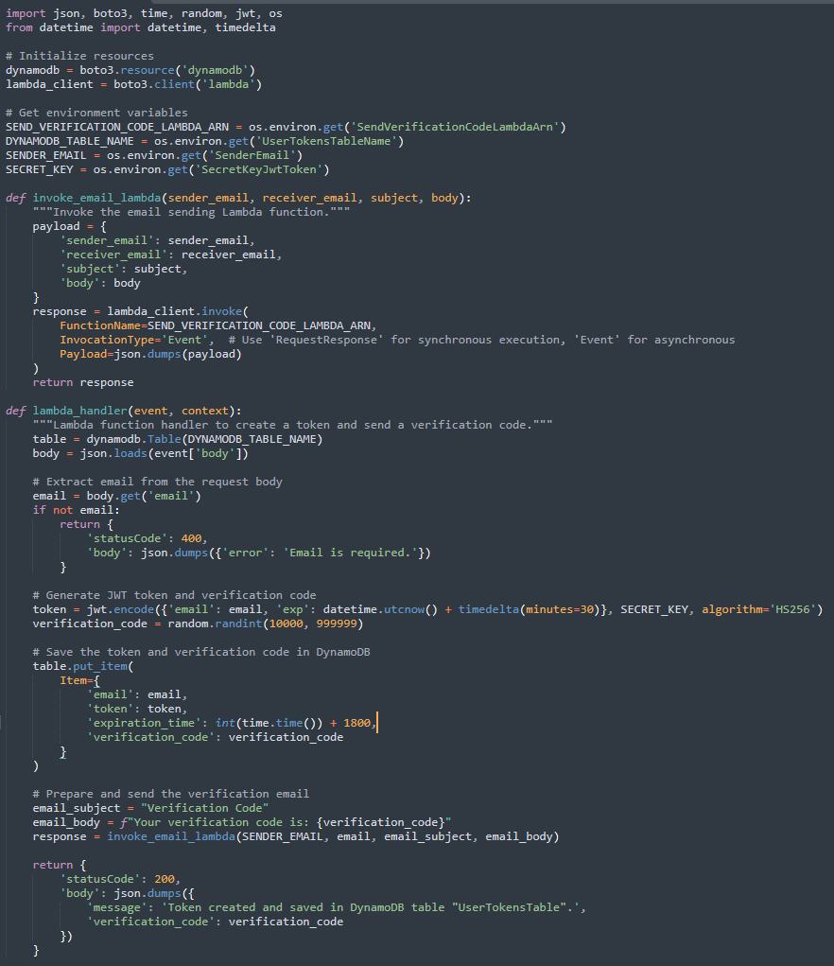

  - Token Sending Lambda Function
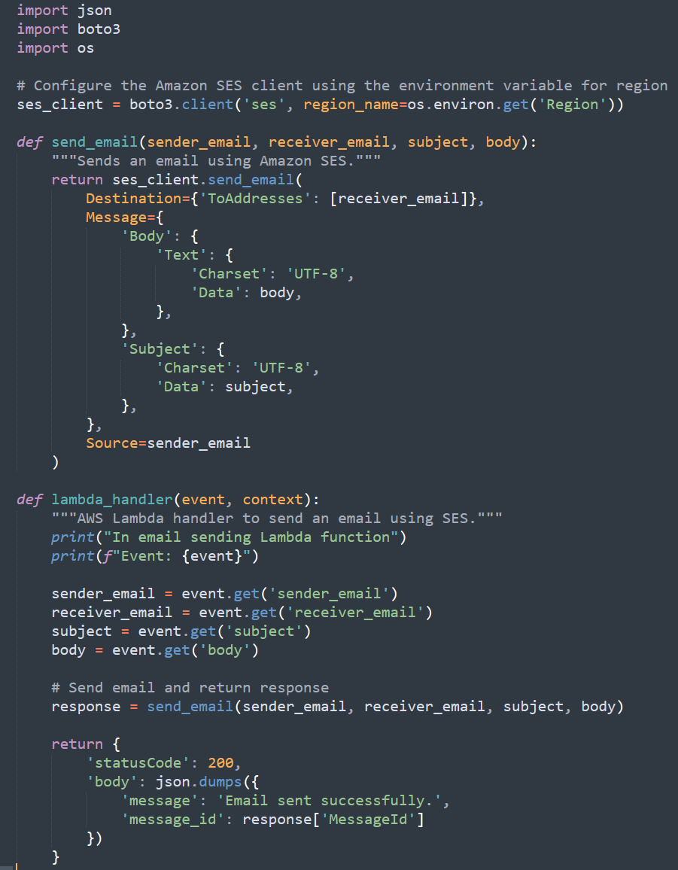

  - Token Verification Lambda Function
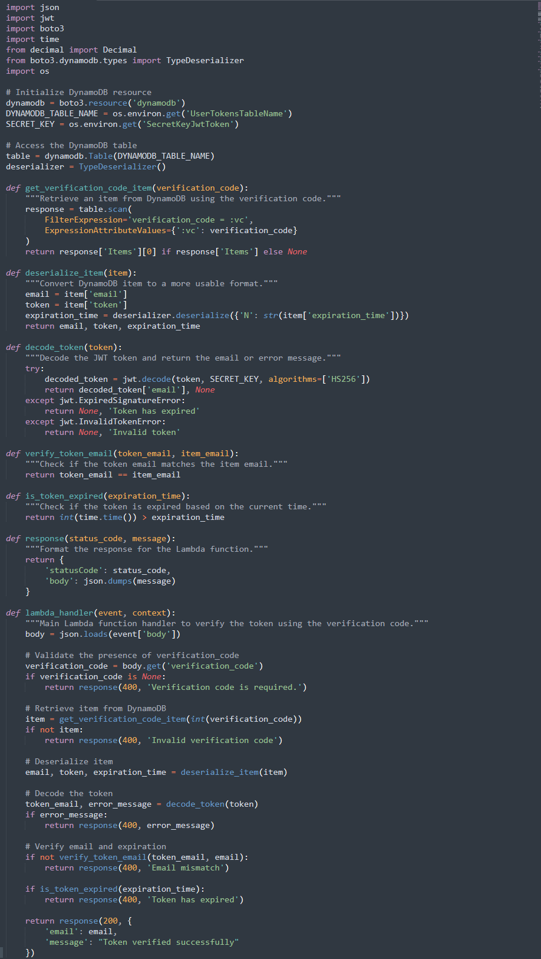

- Implementation Steps
  - Clone the repository: Start by cloning the GitHub repository containing the source code and configuration files to your local machine.
git clone https://github.com/mumtaz4118/aws-serverless-2fa-token-service.git
cd aws-serverless-2fa-token-service
  - Upload Lambda Function ZIPs to S3: Use the provided upload_files_to_s3.sh script to generate and upload the Lambda function ZIP files and the JWT Python library to your specified S3 bucket. Ensure to update your AWS credentials and parameters in the script before execution.
./upload_files_to_s3.sh
  - Deploy Infrastructure via CloudFormation: Access the AWS Management Console and navigate to the CloudFormation service. Create a new stack using the aws-serverless-2fa-token-service.yaml template, providing the required parameters such as Region, Account ID, and DynamoDB table name.
  - Testing the API: After the stack creation completes, copy the TokenCreationAPIURL from the outputs. Use Postman to make a POST request to this URL with a JSON object containing the user’s email. Then, test the token validation using the TokenVerificationAPIURL and the corresponding verification code.
Following these steps will successfully set up the serverless 2FA Token Service, enabling secure token generation and validation workflows.

- Security Best Practices and Future Directions
Implementing robust security measures is crucial for the AWS Serverless 2FA Token Service to protect user data and ensure the integrity of the authentication process. Here are some key security best practices to follow:
  - Least Privilege IAM Roles: Utilize AWS Identity and Access Management (IAM) to define roles and policies that grant only the minimum permissions necessary for each Lambda function and service. This approach reduces the risk of unauthorized access to resources.
  - Enable Encryption:
- At Rest: Enable encryption for data stored in Amazon DynamoDB to protect sensitive information, such as tokens and user metadata.
- In Transit: Ensure that all API Gateway endpoints use HTTPS to encrypt data transmitted between clients and the service, preventing eavesdropping and man-in-the-middle attacks.
  - Input Validation: Implement strict input validation in Lambda functions to prevent injection attacks. Ensure that all user inputs are sanitized and checked against expected formats.
  - Rate Limiting: Configure rate limiting on API Gateway to prevent abuse and mitigate denial-of-service (DoS) attacks. This limits the number of requests a user can make in a given time frame.
  - AWS WAF Integration: Use AWS Web Application Firewall (WAF) to protect against common web exploits, such as SQL injection and cross-site scripting (XSS), by applying custom rules that filter and monitor incoming traffic.
  - Token Expiration: Set short expiration times for generated tokens (e.g., 5 to 30 minutes) to minimize the window of opportunity for unauthorized access. Automatically delete tokens from DynamoDB after they are validated or expired.
  - Logging and Monitoring: Use Amazon CloudWatch to monitor Lambda function executions, API Gateway requests, and other metrics. Set up alerts for unusual activity, such as high error rates or unexpected traffic patterns.
  - Secure Environment Variables: Store sensitive information, such as secret keys and database connection strings, in encrypted environment variables within Lambda functions. This prevents exposure of sensitive data in the codebase.
  - Periodic Security Audits: Regularly review and audit IAM policies, Lambda configurations, and other security settings to identify and rectify potential vulnerabilities or misconfigurations.
By implementing these security best practices, the AWS Serverless 2FA Token Service can effectively safeguard user data and enhance the overall security of the authentication process.
In conclusion, the AWS Serverless 2FA Token Service provides a robust and scalable solution for generating and validating single-use tokens for two-factor authentication, leveraging the power of AWS serverless architecture. By employing key services such as API Gateway, AWS Lambda, and DynamoDB, the system ensures high availability, security, and ease of maintenance. The implementation of best practices in security, monitoring, and modular design not only enhances the user experience but also protects sensitive data, making this service an effective choice for organizations looking to bolster their authentication workflows.

